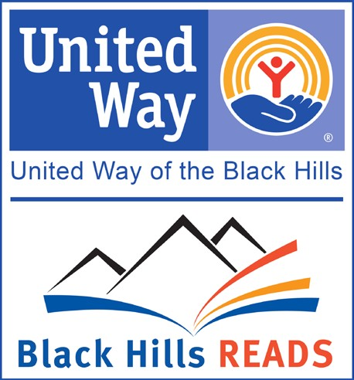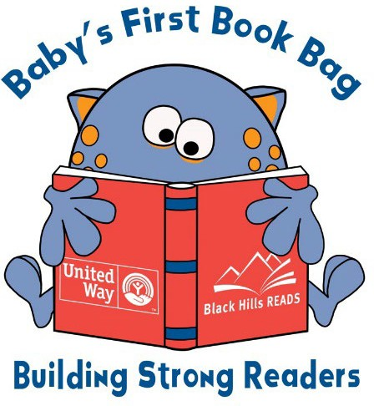**Baby’s First Book Bag**

Partnership Agreement

In signing this agreement, your organization, , agrees to collect the following information from any Baby’s First Book Bag recipient upon distribution of the bags, and again 12 months later:

1. How old is the participating child?
2. How often does the parent/guardian read to the child?
3. How many books do the parent/guardian currently have in their home?

Your organization also agrees to provide Black Hills Reads with data by completing a feedback survey 12 months from receiving the bags and/or at the time of your next request. We will ask you about your experience with Baby’s First Book Bag and what did and did not work well for the clients you served.

A Baby’s First Book Bag training is available for partnering organizations. Black Hills Reads requests that any new organizations receiving these bags send at least one representative to attend this short (10-15 minutes) training before the bags are distributed. To schedule the training, please send an email to [lisa@unitedwayblackhills.org.](mailto:hanna@unitedwayblackhills.org)

Name of Organization

Printed Name of Organization Representative

Signature of Organization Representative

Date Number of Bags Received

Last updated May 2025